WHITEMAN AIRPORT

Volume 6, Issue 10 October 2007
News & Announcements:
Photo of the Month
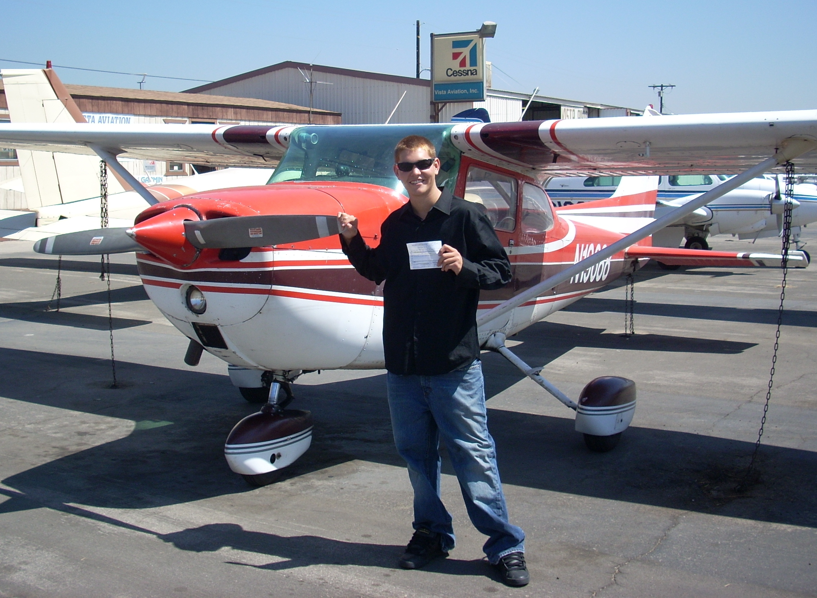

New Pilot at Whiteman Airport:
Dan Fallman, American Airports employee at Whiteman Airport and participant in AAC’s Flight Training Reimbursement Program, seen here with ticket in-hand, recently passed his final checkride. Congratulations, Dan!
October Commission Meeting
The October Commission Meeting will be
held on Wednesday, the 24th, at Whiteman Airport, and will begin at 7:00 pm in Rocky’s Restaurant.

Spotlight on…

Challenge Air is coming to Los Angeles!
Challenge Air for Kids & Friends, in coordination with American Airports, will be holding its first ever “Fly Day” event in L.A. at Whiteman Airport on November 3, 2007.
Challenge Air for Kids & Friends is a national, nonprofit organization that offers motivational, inspirational, and life-changing experiences to physically challenged children and youth through aviation.
Challenge Air events are designed for all special needs, physically challenged and seriously ill children and young adults. Numerous events have been held throughout the United States and have included children from wheelchair athletic groups, hospitals, therapy/rehab programs, the Blind and Deaf association, United Cerebral Palsy, Easter Seals Society groups, Spina Bifida Association groups, American Cancer Society groups and many others.
Highlights of the November 3rd event are anticipated to include an educational ground school, a 30-minute flight over L.A., face painting, clowns, static aircraft, food and beverages, service animals and much more.
We’re pleased that Challenge Air has chosen the L.A. County system of airports for this event – let’s make it a memorable one!
Event: Challenge Air for Kids & Friends
Date: Saturday, November 3, 2007
Place: Whiteman Airport
12653 Osborne Street
Pacoima, CA 91331
Contact Information for sponsors, volunteers, pilots and participants (physically challenged children):
Website: www.challengeair.com
Telephone: Lonna Gibson, Challenge Air
(818) 897-0898
Jason Morgan, American Airports
(818) 896-5271

Inside This Issue
1 | News & Announcements
1 | Spotlight on…
2 | For Sale or Lease
2 | From the Manager
2 | Calendar of Events

From the Manager:

As indicated in the Spotlight article on the cover of this month’s newsletter, Challenge Air for Kids & Friends is coming to Whiteman Airport on November 3, 2007. I am happy to say that many volunteers from Whiteman Airport – Airport tenants and business owners, members of the Airport Association, SFV 99s and Experimental Aircraft Association and others – have stepped up to help out with the event.

Whiteman Airport regularly plays host to numerous public service events, most of which are aviation-related. This Challenge Air event is another way that Whiteman Airport can add value to the community through introducing general aviation and the joy of flight to local challenged youth.

If you would like to volunteer in any way for this event or make a donation of any size, please contact me at (818) 896-5271 or via e-mail at jmorgan@americanairports.net.

Airport Enhancements / Updates

We recently installed two new hoses, high pressure hose nozzles, and an automatically retracting hose-reel at the wash rack. We hope that this new equipment will improve your ability to clean your aircraft. Your efforts to help us maintain this equipment and keep us advised of any missing or damaged equipment are greatly appreciated.

Airport Safety / Security / Operational Items
You may have noticed the police officers patrolling the Airport each day. The Los Angeles County Department of Public Works has a contract with the L.A. County Police Department to patrol Whiteman Airport twice each day – spending a total of at least 2 hours on the Airport each day.

These patrols certainly provide an added level of security and we want to maximize this contribution. I welcome any of your comments and/or suggestions regarding the L.A. County Police Department’s role in helping us to maintain a safe and secure Airport.

FAA Monthly Seminars
There is an FAA Safety meeting every month. For meeting information, please see the website at http://faasafety.gov. It is held in the Civil Air Patrol trailer.

Support your Airport Association
Please come out on the 3rd Thursday of each month to Rocky’s Restaurant, and join the Airport Association. For $10 a year in dues, you can help provide input on how to better run your airport. The October meeting will be on the 17th at 7:00 pm.
Jason Morgan, Airport Manager
T: (818) 896-5271 / F: (818) 897-2654
jmorgan@americanairports.net
12653 Osborne St., Pacoima, CA 91331
Need Fuel?
Call on UNICOM 122.95 or by phone at (818) 312-2911
AAC Customer Service: (310) 752-0578 or email AACService@americanairports.net
Accounting Customer Service: (310) 752-0559
Our website: www.americanairports.net

For Sale or Lease:

Brackett Airport: (909-593-1395)
Tie Downs – From $52.00 / month
Standard T’s – From $408.00/month
Executive Hangars 1,824 sq ft – From $724/month
Compton Airport: (310-631-8140)
Tie Downs – From $49.00 / month
El Monte Airport: (626-448-6129)
Tie Downs – From $60.00/month
Hangars – From $294.00/month
Fox Airfield: (661-940-1709)
Tie Downs – From $54.00 / month
Q Land for Development
Whiteman Airport: (818-896-5271)
Third-party lessee offering 2,500 square feet of office and 2,500 square feet of hangar
(50’ x 50’) for lease – contact (818) 890-7662.

Calendar of Events

1 - Pacoima Rotary Club at Whiteman: 6:00 pm @ WHP Rocky’s
2 - EAA Chapter 49 at Fox: 7:30 pm @ WJF Terminal Building
3 - PEMIA at El Monte: 6:00 pm @ EMT Terminal Building
3 - CAP Squadron 35 at Whiteman: 7:00 pm @ WHP CAP Trailer
4 - Civil Air Patrol at El Monte: 7:00 pm @ EMT Terminal Building
4 - Brackett Pilots’ Association: 7:30 pm @ POC Pilots’ Lounge
6 - SGV Car Show at El Monte: 4pm - 8 pm, EMT Parking Lot
6/7 - Compton Antique Aircraft & Auto Display: 10:00 am -2:00 pm
8 - Pacoima Rotary Club at Whiteman: 6:00 pm @ WHP Rocky’s
9 - SGV Remote Control Assn at El Monte:
7:00 pm @ EMT Terminal Building
10 - CAP Squadron 35 at Whiteman: 7:00 pm @ WHP CAP Trailer
10 - Latin American Pilots’ Assn at Whiteman: 7:30 pm @ Rocky’s 11 - Civil Air Patrol at El Monte: 7:00 pm @ EMT Terminal Building
11 - Brackett 99s: 7:30 pm @ POC Pilots’ Lounge
13 - SGV Car Show at El Monte: 4pm - 8 pm, EMT Parking Lot
13 - Fox Airfield Open Hangar Day (all day)
14 - Whiteman Display Day: 10 am-2 pm
15 - Pacoima Rotary Club at Whiteman: 6:00 pm @ WHP Rocky’s
17 - PEMIA at El Monte: 6:00 pm @ EMT Terminal Building
17 - CAP Squadron 35 at Whiteman: 7:00 pm @ WHP CAP Trailer
18 - Civil Air Patrol at El Monte: 7:00 pm @ EMT Terminal Building
18 - Whiteman Airport Association Meeting: 7:00 pm @ Rocky’s
20 - SGV Car Show at El Monte: 4pm - 8 pm, EMT Parking Lot
20 - EAA Chapter 96 at Compton: 10:00am, EAA Hangar
21 - Brackett Antique Aircraft & Auto Display:
10:00 am – 2:00 pm @ POC Transient Parking Lot
22 - Pacoima Rotary Club at Whiteman: 6:00 pm @ WHP Rocky’s
23 - SGV Remote Control Assn at El Monte:
7:00 pm @ EMT Terminal Building
24 - CAP Squadron 35 at Whiteman: 7:00 pm @ WHP CAP Trailer
24 - L.A. County Aviation Commission Meeting at Whiteman
7:00 pm @ Terminal Building
25 - Civil Air Patrol at El Monte: 7:00 pm @ EMT Terminal Building
25 - Pomona Valley Pilots’ Association at Brackett:
7:30 pm @ POC Pilots’ Lounge
27 - SGV Car Show at El Monte: 4pm - 8 pm, EMT Parking Lot
28 - El Monte Vintage Airplane & Auto Display:
9:00 am – 1:00 pm @ EMT Center Field
29 - Pacoima Rotary Club at Whiteman: 6:00 pm @ WHP Rocky’s
31 - CAP Squadron 35 at Whiteman: 7:00 pm @ WHP CAP Trailer

